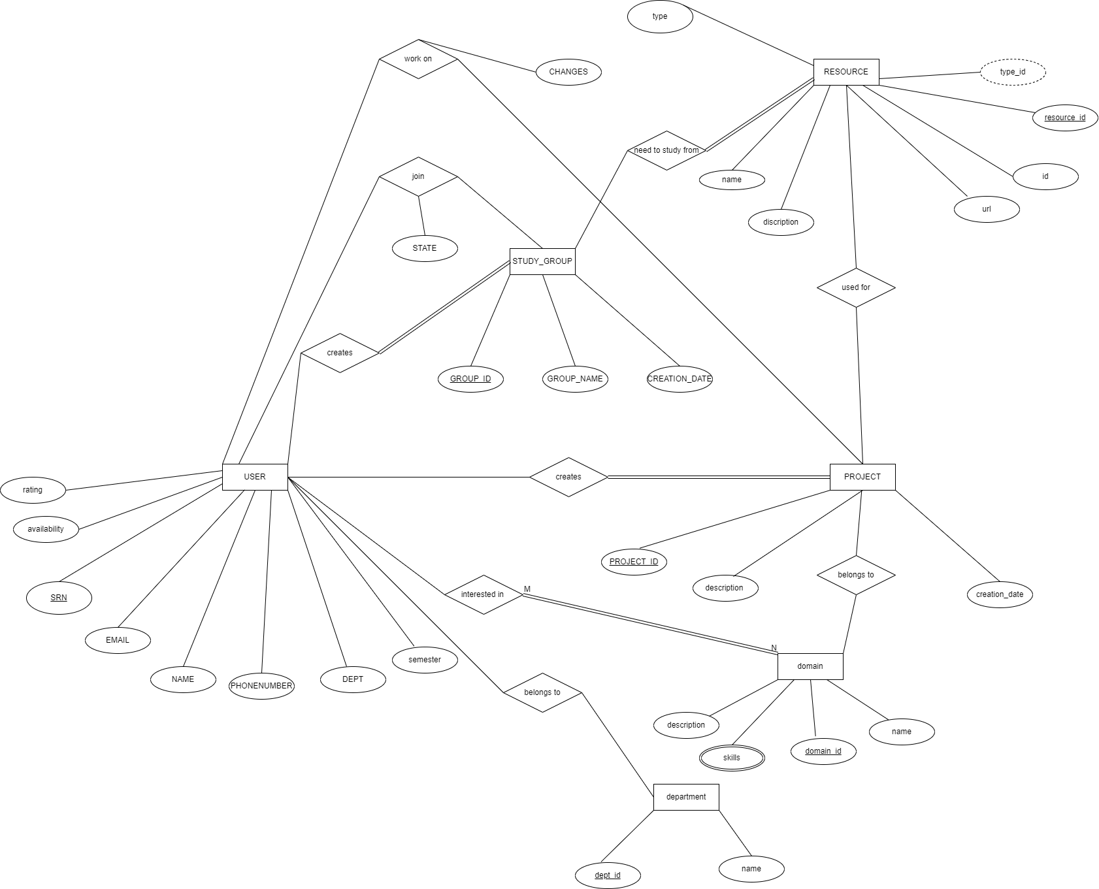

Converting ER Relational mapping

* Step 1: Mapping of Regular Entity Types.

Here The Strong entities are:

USERS

DEPARNMENT

PROJECTS

STUDY_GROUPS

DOMAIN

RESOURCES

Making the relational schema for String entities:

* Step 2: Mapping of Weak Entity Types

In user

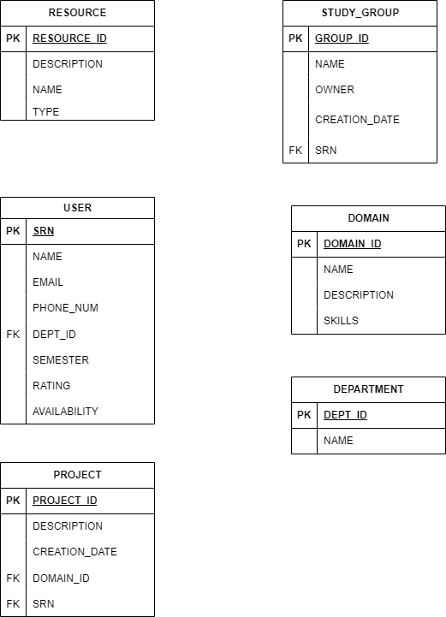

* **Step 3: Mapping of Binary 1:1 Relation Types**

There is no 1:1 mapping in our database

* Step 4: Mapping of Binary 1:N Relationship Types.

Here

* + Users belong one department so dept_id is put into the table as foreign key .
  + Projects can have one owner so SRN is added as the foreign key .
  + Study_groups can have one owner so SRN is added as the foreign key.
  + Projects belong to one domain so domain_id is added as foreign key.
* **Step 5: Mapping of Binary M:N Relationship Types.**

Here

* Users can work on many projects so we create a new table called works_on.
* Users can be a part many study_groups so we create a new table called joins.
* Projects can use many resources so v need to create a table called resouces_used.
* **Step 6: Mapping of Multivalued attributes.**

We don’t have any multi valued attributes.

* **Step 7: Mapping of N-ary Relationship Types.**

We don’t have any N-ary relationship.

The resulting relation schema will be this

